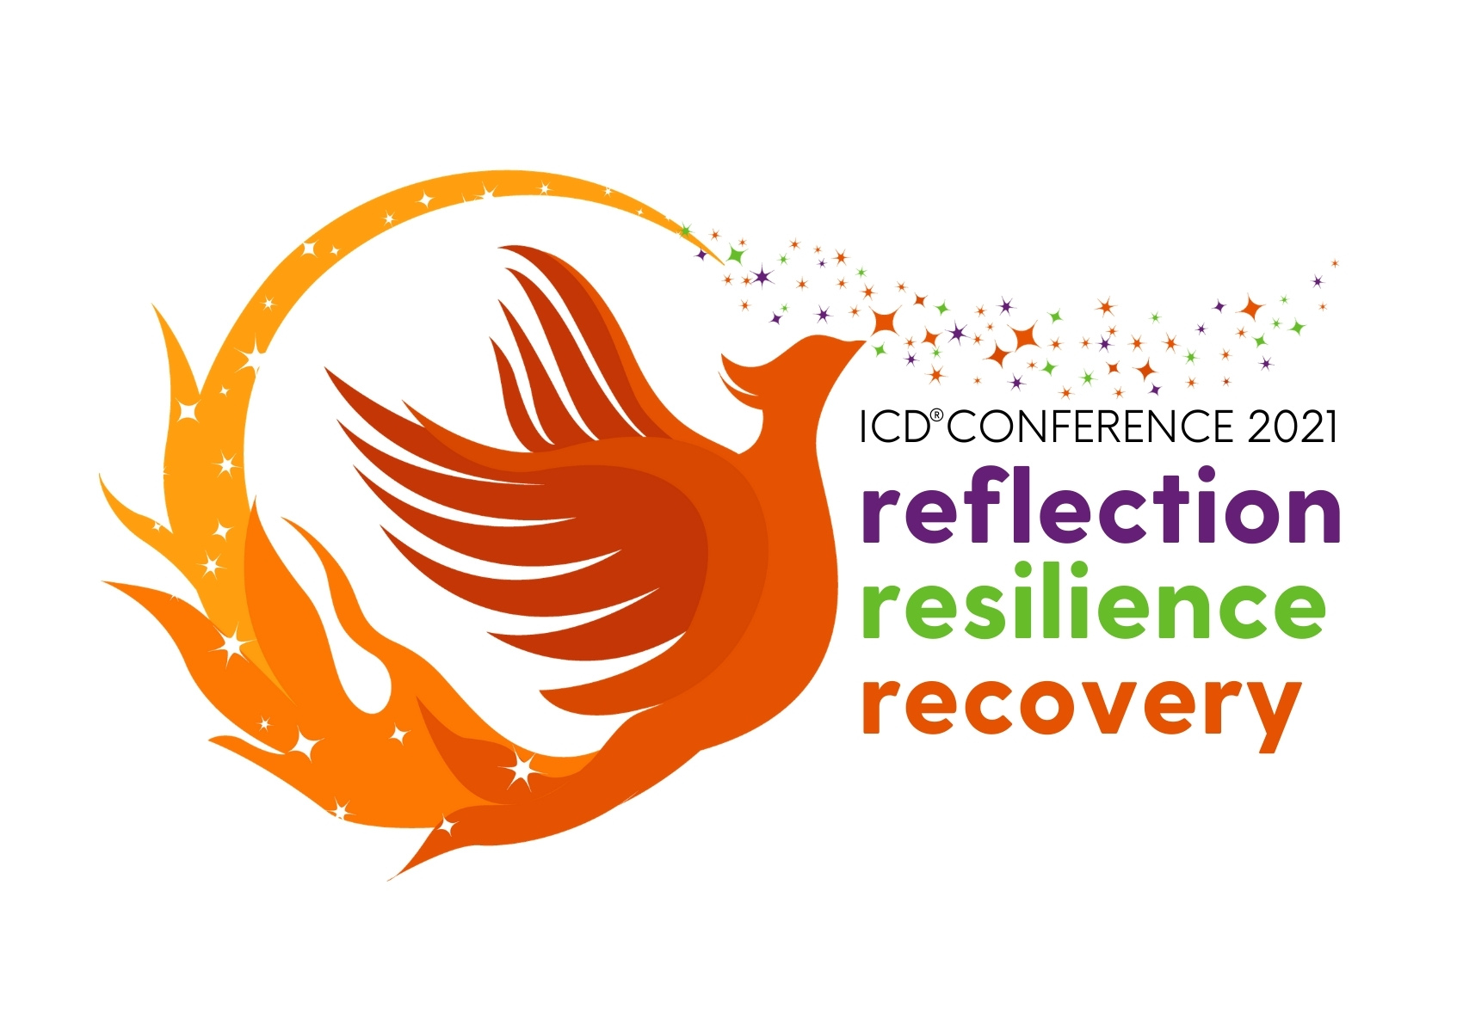

Press Release ICD® Online Conference 2021

FOR IMMEDIATE RELEASE

Date | August 26, 2021
ICD® Contact | Nacho Eguiarte, CPO®, Events Director
Email | events@challengingdisorganization.org

The Institute for Challenging Disorganization® (ICD®) is proud to announce this year’s online conference will be held from October 13 – 17, 2021. The conference theme is “Reflection, Resilience & Recovery.”

ICD® is a nonprofit dedicated to providing education, research, and strategies to benefit people challenged by chronic disorganization and the people who work with them. Our community is primarily made up of Professional Organizers, Productivity Specialists, and other related professionals who want to learn more about clients affected by chronic disorganization.

“Chronic disorganization” is not a disease, but rather a consequence of brain-based challenges, unhelpful beliefs about themselves and their possessions, serious or chronic illnesses, or life transitions. Because of these underlying factors, traditional organizing methods are generally not helpful to people challenged by chronic disorganization.

From ten outstanding presenters this year, two of the most well-known are Edward (Ned) Hallowell, M.D., board-certified child and adult psychiatrist, and the author of 20 books including Driven to Distraction, and Russell A. Barkley, Ph.D., board-certified in Clinical Psychology (ABPP), Clinical Child and Adolescent Psychology, and Clinical Neuropsychology, and author of 15 books including Taking Charge of ADHD, The Complete Authoritative Guide for Parents. They are both internationally recognized authorities on attention deficit hyperactivity disorder (ADHD or ADD).

Visit the website for more information at www.challengingdisorganization.org/2021-icd-conference, or email Events@challengingdisorganization.org.
###

